Optional Assignment 3
Kernel Compilation
Manavjeet Singh,2018295

Creating the Virtual Machine
- Install QEMU. sudo pacman -S qemu
- Create a Virtual Hard Drive of size 50GB for the Virtual operating system(ParrotSec) using command: qemu-img create parrot.img 50G
- Download ParrotSec ISO from its Website
- Boot up the virtual machine from the ParrotSec ISO on virtual drive parrot.img with 2GB ram assigned to the virtual machine. Using command: qemu-system-x86_64 -hda parrot.img -enable-kvm -cpu host -boot d -vga virtio -cdrom ./ISOs/Parrot-security-4.7_x64.iso -m 2048
- Follow the prompt to install Parrot sec on the virtual machine
- Boot up the virtual machine from the virtual drive using the command: qemu-system-x86_64 -hda parrot.img -enable-kvm -cpu host -boot d -vga virtio -m 2048

Compiling Kernel
- Download kernel 5.5.5.tar.xz.
- Extract the kernel source
- Install dependencies using command: sudo apt-get install build-essential linux-source bc kmod cpio flex cpio libncurses5-dev
- Change the config file so that it won’t give error while compiling: CONFIG_SYSTEM_TRUSTED_KEYS = ""
- cd to the root folder of the kerenel source folder
- Copy the config file of the current kernel into the current working directory, this will tell which modules to include while compilation. Use command: cp /boot/config-$(uname -r) .config
- Use command make menuconfig to create the new config file
- Use command make to compile the kerenel
- Install the compiled modules using: make modules_install
- Install the kernel in /boot directory using the command: sudo make install
- Create the initial ram file system using the command:sudo update-initramfs -c -k 5.5.5
- Update the GRUB2 bootloader using the command: sudo update-grub

Output of uname -a
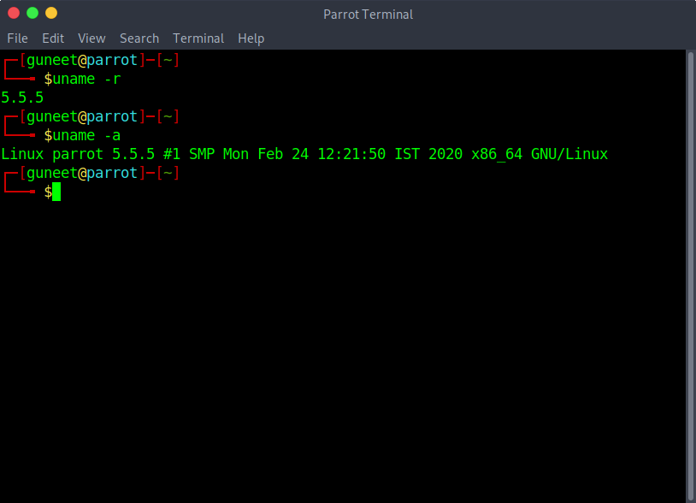
Linux parrot 5.5.5 #1 SMP Mon Feb 24 12:21:50 IST 2020 x86_64 GNU/Linux

